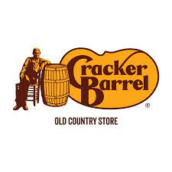
Apply on indeed.com or Cracker Barrel, https://tinyurl.com/27yvvscx

Retail Sales- job post
Cracker Barrel
970 W. Pointe Ct., Lithia Springs, GA 30122
Full-time, Part-time

Host- job post
Cracker Barrel

970 W. Pointe Ct., Lithia Springs, GA 30122
Full-time, Part-time

To-Go Hospitality- job post
Cracker Barrel

970 W. Pointe Ct., Lithia Springs, GA 30122

Dishwasher- job post
Cracker Barrel

970 W. Pointe Ct., Lithia Springs, GA 30122
Full-time, Part-time

