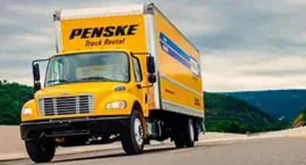

When: Tuesday, September 21, 2021 @ 6:30PM
What: Penske Hiring Information Session
Where: Join Zoom Meeting
https://us02web.zoom.us/j/84776222658
Meeting ID: 847 7622 2658

Penske Truck Leasing is hiring for the following positions:
- Vehicle Preparation Representative – this role is responsible for washing, detailing and fueling trucks. Along with a comprehensive benefits package, you can expect to earn $18.12 per hour at most locations. This is a great position if you are interested in being a mechanic but don’t yet have the skills or ability. We will train you to be a diesel mechanic.

- Diesel Mechanic – Entry Level – Do you already have experience working on automobiles and want to expand your knowledge to diesel, well we may have a position for you. This role starts at $20 at most locations.

- Sales and Operations Management Trainee – Must have a Bachelor’s Degree. Do you want to work in sales or what about management, this maybe the path for you? This position starts at $21 per hour.
Learn more about Penske:
Penske Video: https://youtu.be/2gNxP04N06o
Penske Who We Are

For more information please contact:

Carla Howard, Site Coordinator
Communities In School of Georgia
Peeblebrook High School
(770) 819-2521 EXT 1082 Office
(678) 561-2896 Mobile
carla.howard@cobbk12.org
choward@cisgeorgia.org

